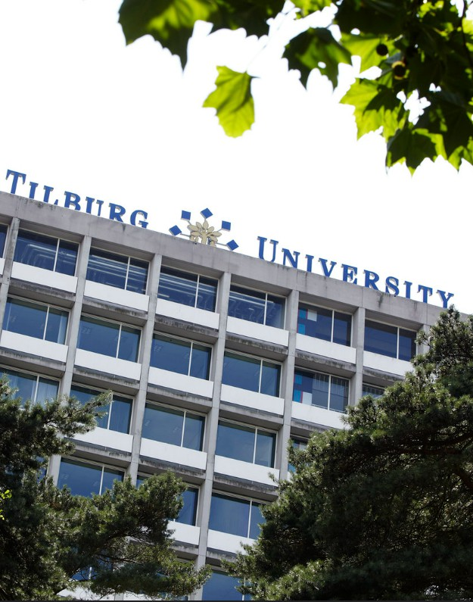

Hora Finita
  - Manual
  - (Co-)Supervisor
gra

Contents
1. Introduction 3
2. Practical Information 3
2.1 Check your details 3
2.2 Login to Hora Finita 5
2.3 Saving Data 5
2.4 Returning to Previous Page 5
2.5 E-mails end up in spam 6
2.6 URL not working 6
2.7 Other IT-related issues 6
3. General 7
3.1 General Overview 7
3.2 Extra Information 7
3.2.1 PhD Projects 8
3.2.2 Cum Laude 8
3.2.3 Training Activity 9
3.2.4 Support 10
4. Approvals 10
4.1 PhD Track 10
4.2 Training and Supervision Plan (TSP) 11
4.3 Assessing the Manuscript 12
4.4 PhD Committee 14
4.5 Final version of the Manuscript (only TiSEM) 14

Tilburg University
Hora Finita
Manual (Co-)Supervisor
Version March 2023

1. Introduction

Hora Finita is the platform that is used for the registration of all PhD Projects at Tilburg University. All PhD related processes are present within Hora Finita, from the registration phase to the defense.

In your role as (co-)supervisor, you will be tasked with monitoring the progress of the PhD candidates that fall under your supervision. In Hora Finita, you will assess the Training and Supervision Plan, propose a PhD Committee and approve or reject the PhD Candidate’s Manuscript.

If you have any questions regarding Hora Finita, feel free to contact the key-user of your graduate school.

Graduate School | Key-user | E-mail | Phone
TiSEM | Ank Habraken | center-gs@uvt.nl | +31 (0)13 466 3102
TLS | Rowenda Makkelie | law.doctroral_degree@uvt.nl | +31 (0)13 466 8722
TSHD | Karlijn Herforth | tshd.graduateschool@uvt.nl | +31 (0)13 466 3494
TSB | Carla de Jongh | graduateschool.tsb@uvt.nl | +31 (0)13 466 2952
TST | Jack de Mooij | tst.graduateschool@uvt.nl | +31 (0)13 466 3845
DB | Tineke van Stralen | doctorate.board@uvt.nl | +31 (0)13 466 2230

2. Practical Information

2.1 Check your details

In order to access Hora Finita, you will have to use login information that is given by Tilburg University. If you are an internal employee, you will already have an ANR and login information from HR services. When this is not the case, and you have not received your login information by any other means, please contact the Key-user of the graduate school that you are affiliated with. See the information before this section to know which Key-user you should contact.

After you have received your ANR, with the correspondent login information, you will have to check your personal details in My Employee Portal.

Go to the Intranet page at https://www.tilburguniversity.edu/intranet. Use your login information and click "My Employee Portal" to access your personal information (see next page).

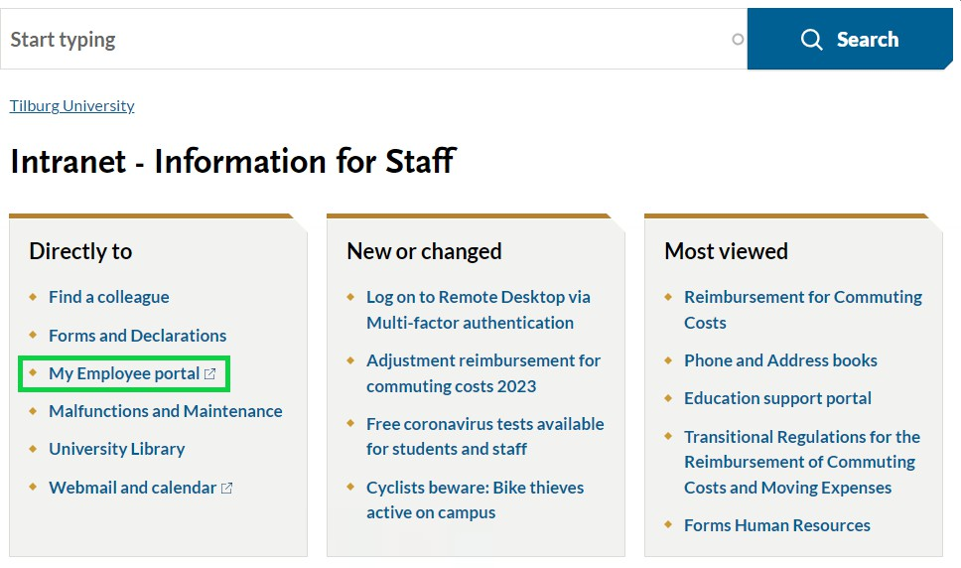
In the quick actions menu, click on “My Data”.
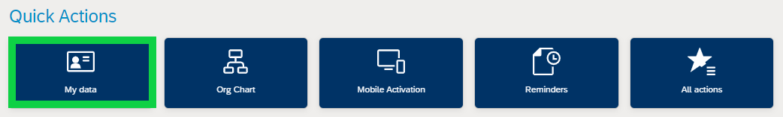

Please verify whether the information that is shown here is the same as in Hora Finita, as Hora Finita uses HR data to create your profile. If you see incorrect information and you are not able to change it yourself, please contact the Graduate Office for support.

After you have updated your information in My Employee Portal, it takes approximately 2 days to be automatically updated in Hora Finita.

2.2 Login to Hora Finita
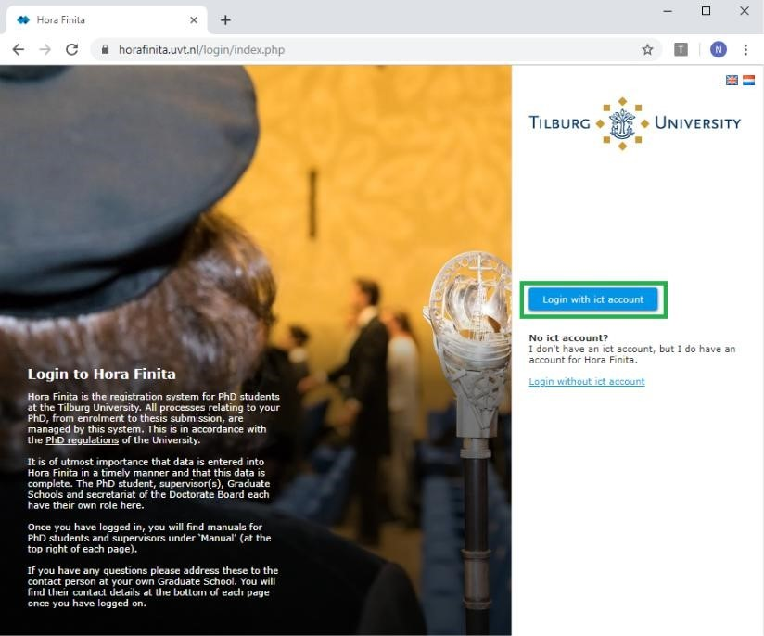
You can access Hora Finita through the following browsers:

- Chrome (preferred)
- Firefox
- Edge
- Safari

To ensure that you can utilize all of Hora Finita's functionalities, please verify whether you have the latest version of your browser installed.
To login on Hora Finita, please go to https://horafinita.uvt.nl and click on ‘Login with ict account’. Use your regular Tilburg University login information to log in to the system.

2.3 Saving Data

Hora Finita has a timer that monitors inactivity, automatically logging you out after one hour of inactivity. To ensure that your work is saved, please ALWAYS save your data after moving on to another activity, or logging out. THE SYSTEM WILL NOT SHOW A WARNING, IF YOU DO NOT SAVE YOUR WORK ALL UNSAVED DATA WILL BE LOST.

The button saves the current page and goes back to the previous page afterwards.
The button saves the current page, but you will remain on the same page.

2.4 Returning to Previous Page

You have two possibilities to return to the previous page:
- By clicking the button
- By using the previous page function of your browser
Please make sure to save all entered data and changes before you leave the page.

The fields marked with an asterisk (*) are compulsory. When leaving these fields empty, Hora Finita will give an error and will mark the fields that still have to be filled out in red.

2.5 E-mails end up in spam

If Outlook categorizes some, or all, of the e-mails sent by Hora Finita as spam, you may contact IT support.

Please call +31 (0)13 - 466 2222

Provide them with service desk number: 19 05 00536. This number allows them to find the relevant information about Hora Finita and the specific issue you are confronted with. The IT team can remotely access the computer using TeamViewer. They will correct any faulty settings within your Outlook profile.

If the PhD Candidate you are supervising is affiliated with TIAS please call +31 (0)13 466 8666

2.6 URL not working

Some e-mails from Hora Finita contain a URL. If one of these URLs is a dead link or not working for different reasons, please try the following solutions:

- Copy and paste the URL into the browser, then click enter.
- Disable your ad-blocker and refresh the page.
- Contact your Graduate School.
- Contact IT Support as explained in the paragraph 2.5.

2.7 Other IT-related issues

Please contact IT Support for other IT-related issues.
- Tilburg University: +31 (0)13 - 466 2222
- TIAS: +31 (0)13 - 466 8666

3. General

3.1 General Overview
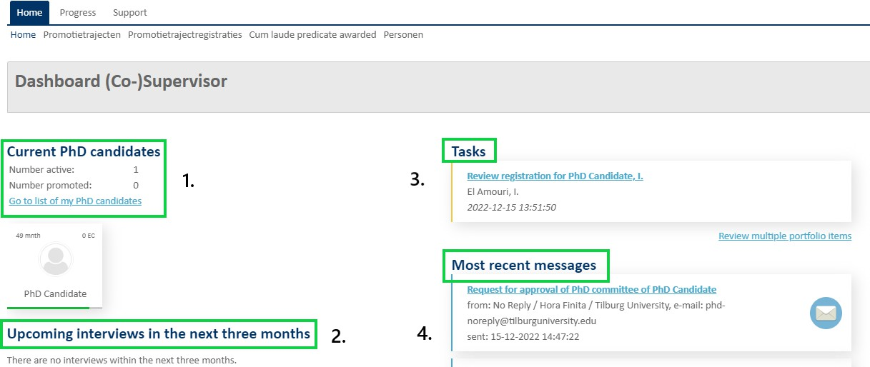

When you log in to Hora Finita you will be able to find an overview of the PhD Tracks you are supervising on the Dashboard (Co-)Supervisor. In the "Home" section you will be able to see that amount of both active and finished PhD Candidates. If you are an education coordinator (EC), you will also see the profiles of the PhD Candidates you are supervising in your role as EC.

- shows the details of your current PhD Candidates and their indicated progress.
When the progress line under the PhD Candidate's name is green, this means that there is good progress. An orange line indicates that attention is necessary, and red signifies insufficient progress. You can click on the PhD Candidate's profile if you would like to see more details.
- shows the upcoming interviews.
- above shows your pending tasks.
- gives an overview of the recent e-mails you have received.
The e-mails will be sent to both your e-mail inbox and Hora Finita.

3.2 Extra Information

In addition to the Home tab, there are also several other tabs you can consult.

3.2.1 PhD Projects

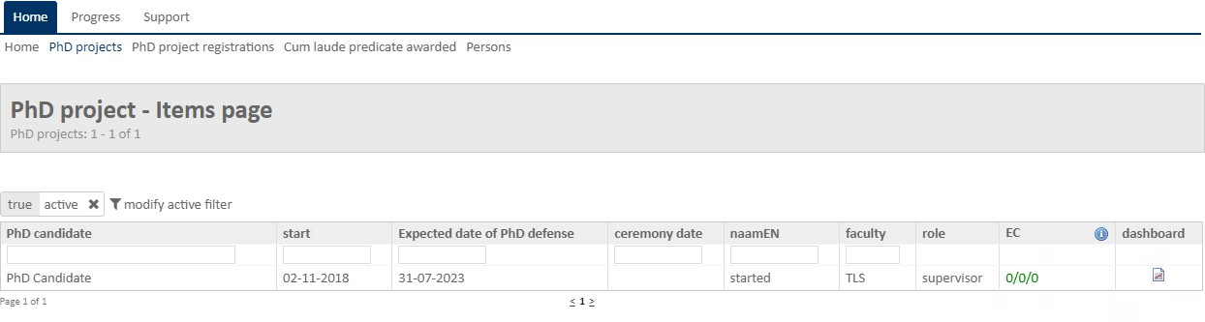
The PhD Projects tab shows you all of the active tracks of PhD Candidates you are supervising.

As seen in the image above, it shows the name of the PhD Candidate, the start of the PhD track (which is usually different than the contract start date), and the expected date of the PhD defense.

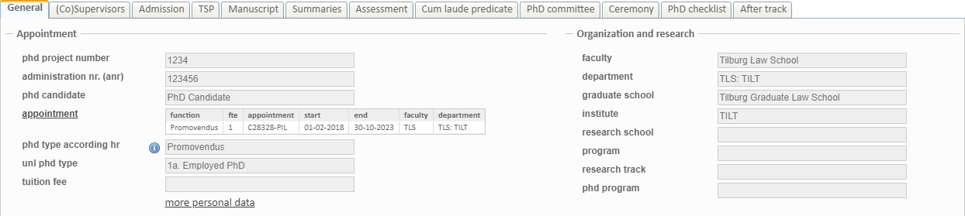
By clicking on one of the PhD Candidate's names, you will be able to access the respective candidate's track details. As a (Co-)Supervisor it is not possible to edit information. Below you see an overview of all the tabs and a snapshot of a PhD Candidate's profile.

3.2.2 Cum Laude

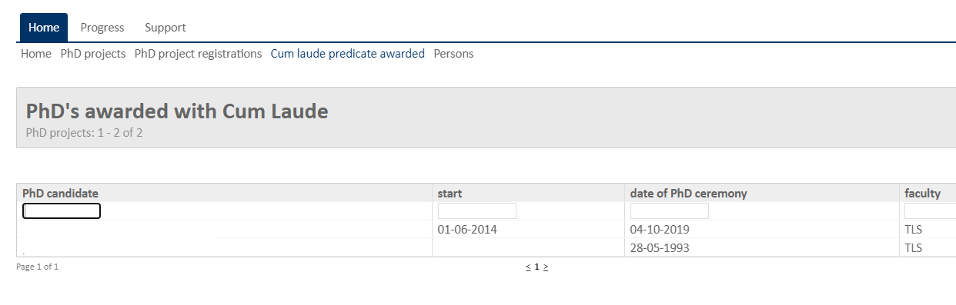
If any of your PhD Students have received a Cum Laude Predicate, they will appear under the tab "Cum laude predicate awarded’’.

3.2.3 Training Activity

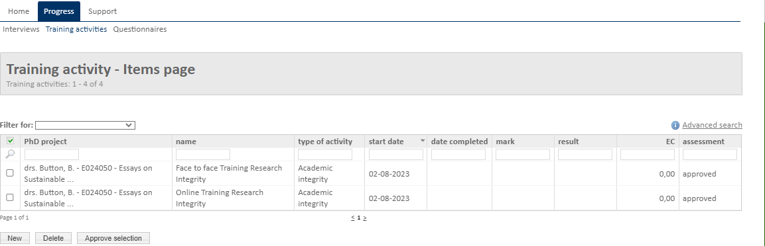
If you click on "Progress" and then at "Training activities", you may find all the courses of your PhD candidates which are mentioned in their Training and Supervision Plan.

If you click on one of the trainings, a more detailed page will open. In the image below, at number 1 you can find descriptive information. At number 2 the number of ECs the course is worth. At number 3 you can download and view the relevant documents. At number 4 you can write down any comments you have. At number 5 you can choose to either approve or reject the portfolio item.

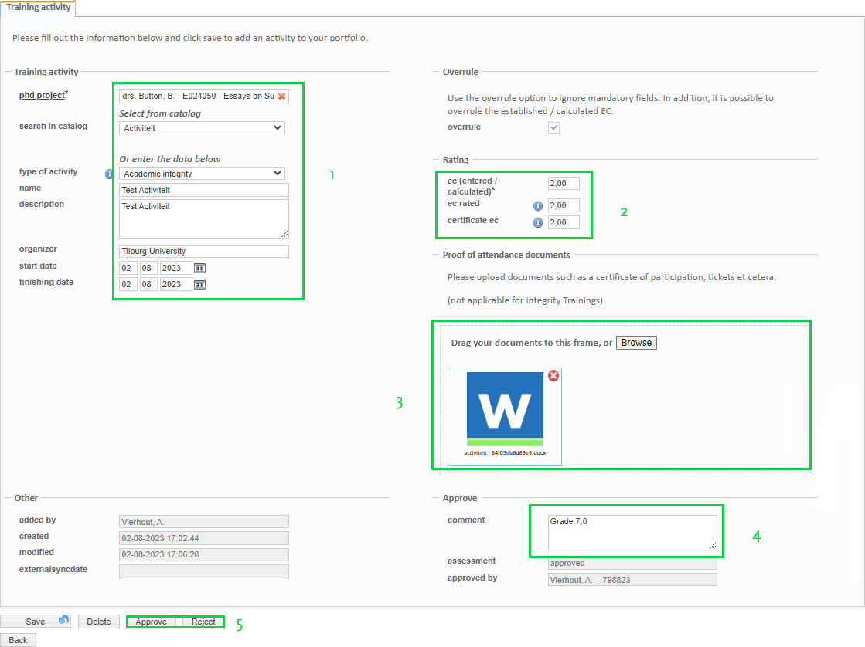

3.2.4 Support

The last tab is the Support tab. Here it is possible to download the Hora Finita Manual, the PhD Regulations and the Code of Conduct of Research Integrity.
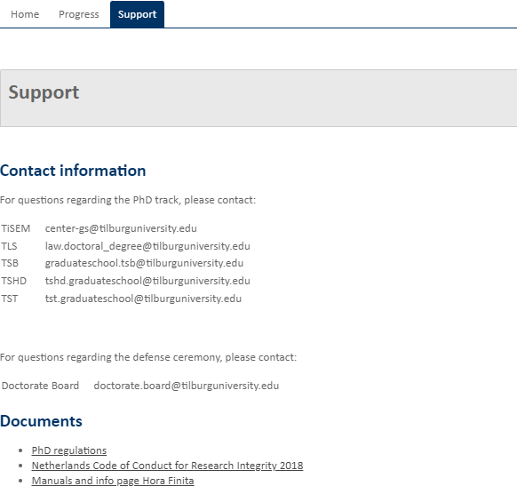

4. Approvals

You will often have to give your approval or rejection during the PhD Project. Every time a proposal needs approval, you will receive an e-mail with specific instructions in it.

If a request is rejected, the process of the PhD Track will be temporarily suspended. The parties involved (PhD Candidate, supervisor, etc.) will receive an automated e-mail with all the necessary instructions.

4.1 PhD Track

The very first step is the approval of the PhD track registration. At the request of the Graduate School, the PhD candidate will fill out all the necessary information in Hora Finita. Once complete, you will receive an e-mail to check the details and confirm your role as (co-)supervisor (see next page).

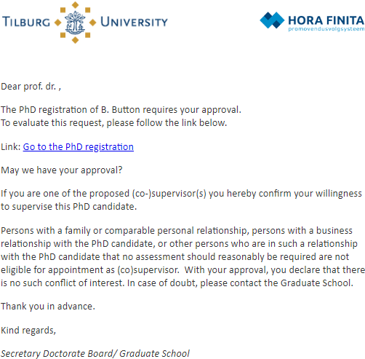
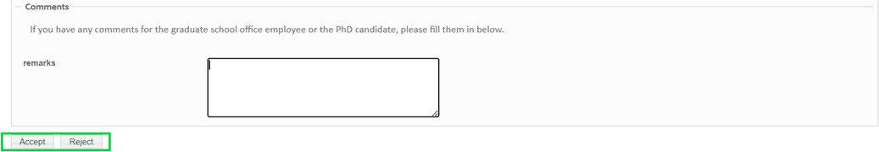
The registration form will open in the browser. By default, the document is set on "Read only", meaning that you cannot change any of the grey fields. At the bottom of the page you will find a box to write your remarks in if necessary. Next you can click Accept or Reject.

Please note that all remarks can be seen by your fellow (co-)supervisors, the Graduate Officers and the PhD candidate.

4.2 Training and Supervision Plan (TSP)

The PhD candidate has to enter the TSP in Hora Finita. After this, you will receive an e-mail with an URL that brings you to the following web page.

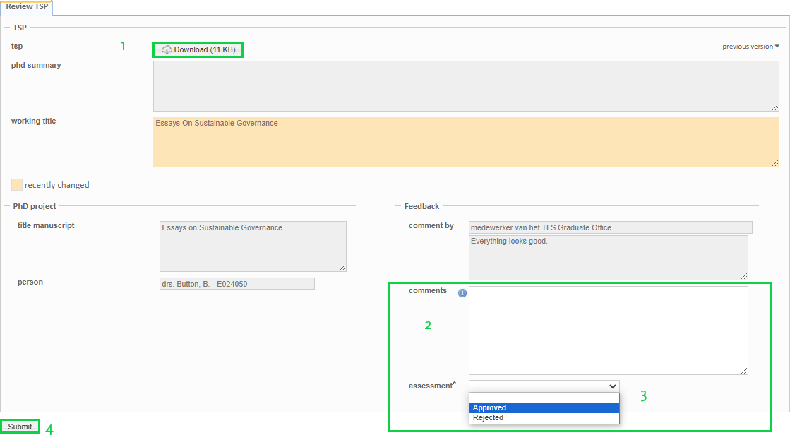
Download the document at the button indicated at "1". Put any comments in the text field indicated with a "2". Then select approved or rejected in the drop down menu at "3". Click on submit at "4" when you have finished. In case of a rejection please make sure your feedback is written down completely, as this will be used by the PhD candidate to improve their TSP. Once approved by you, the TSP also needs to be approved by the Education Coordinator/PhD Coordinator.

4.3 Assessing the Manuscript

All Schools excl. TiSEM: The manuscript will be sent to all (co-)supervisors. You will receive an e-mail with a URL to the web page. Click "download" to download and assess the manuscript. You can either Reject or Approve the manuscript. Write your motivation in the text box. (see the top picture on the next page). At the end of the form you can indicate whether or not you want to propose a Cum Laude predicate. Check the box to propose a Cum Laude Predicate, fill in your motivation and lastly click submit assessment (see the bottom picture on the next page).

When a manuscript is rejected, the PhD candidate needs to be contacted in person by a (co-)supervisor. Afterwards a new manuscript will be uploaded and the process as mentioned here will be repeated.

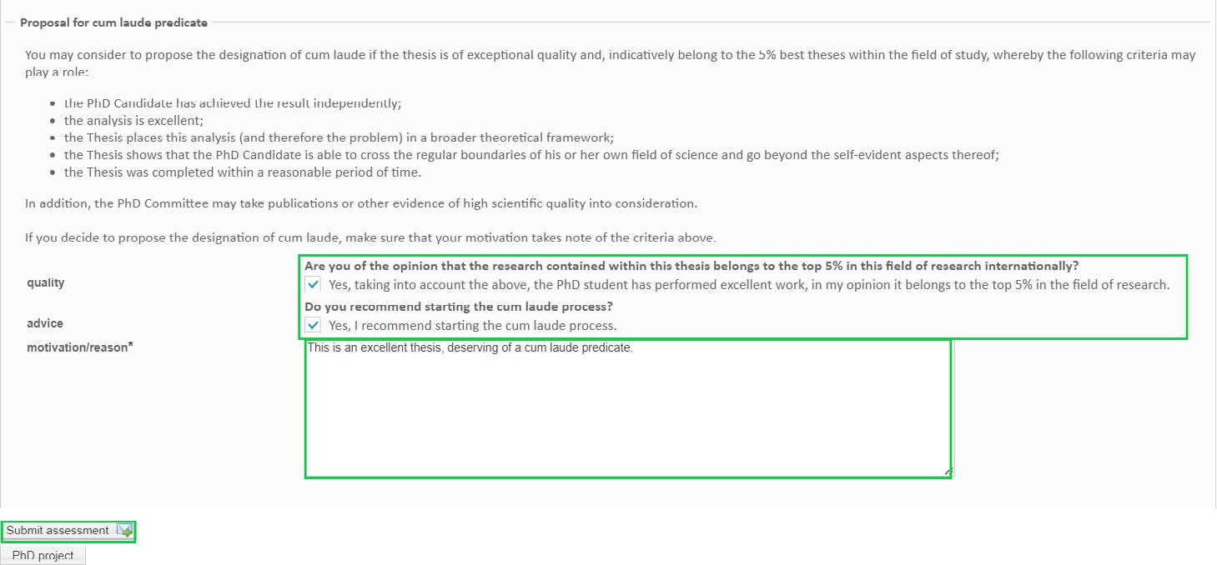
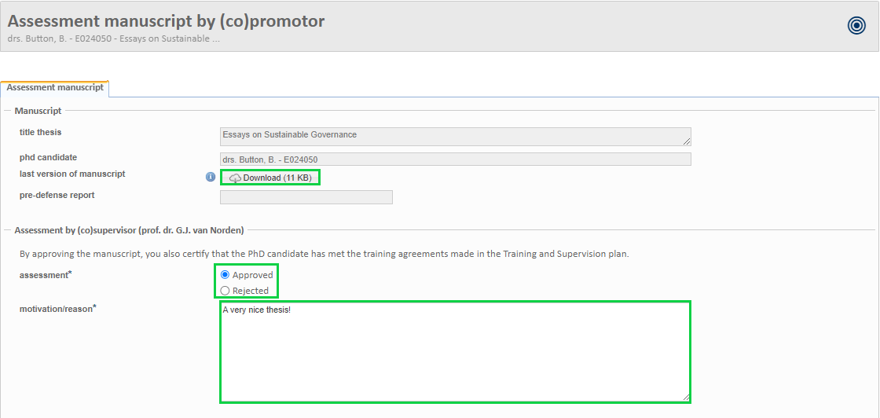

Only for TiSEM: This version of the manuscript will be used for the compulsory predefense. The evaluation form is a simplified version, as this is not the final version of the manuscript. Click on download to retrieve the manuscript file. After you have read it, you can click on the button next to Approved or Rejected and give your motivation in the text box. When you are finished click on "Submit assessment".

4.4 PhD Committee

The proposal of the composition of the PhD Committee has to be sent to the Graduate School Officer by e-mail. Every (co-)supervisor receives an e-mail requesting the proposal of the composition of the PhD Committee to be sent to the Graduate School Officers. Only one of the (co-)supervisors needs to be appointed to fulfill this task. The Graduate School Officer will enter the committee in Hora Finita after which you will be asked to give your approval by an automated e-mail of Hora Finita.

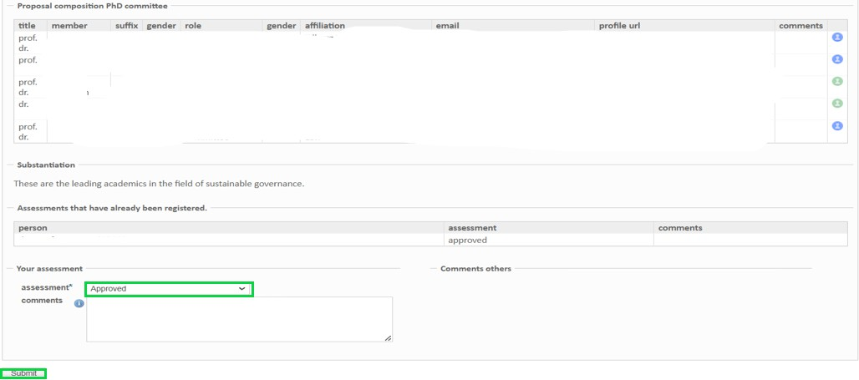
After clicking the URL in the e-mail you will see a table with the proposed committee. At the bottom of the page you can select "Approved" or "Rejected" in the drop down menu and put any comments you might have in the text box. Once all (co-)supervisors have given their approvals, the Director of Graduate School and the Rector will be asked to assess the composition of the committee.

All Schools excl. TiSEM: After the instalment of the PhD Committee and after approval of the manuscript, the manuscript will be sent to the PhD Committee and a ceremony date will be set by the secretary's office of the Doctorate Board.

4.5 Final version of the Manuscript (only TiSEM)

TiSEM PhD candidates will have to resubmit the final version of the manuscript after implementing the comments received during the predefense. The PhD candidate will also upload a predefense report. You will be asked to approve or reject this version of the manuscript by e-mail.

If a manuscript is rejected, the PhD candidate needs to be contacted in person by a (co-)supervisor. They are not automatically notified via e-mail. The manuscript will only be sent to the PhD committee after the Graduate Office has received the assessments of all the (co-)supervisor(s).

Once all Committee members have assessed the manuscript, the (co-)supervisor(s) will be informed about the outcome. It is not possible to check the assessments during the assessment process. After submission of this second manuscript, the defense ceremony date will be set by the secretary's office of the Doctorate Board.

